***Lecture Three − Infinite Sequences and Series***

***Section* 3.1 – Sequences**

A sequence is a list of numbers



An ***infinite sequence*** of numbers is a function whose domain is the set of positive integers. These are the ***terms*** of the sequence. The integer ***n*** is called the ***index*** of .

Sequences can be described by writing rules that specify their terms such as



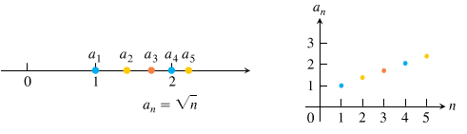



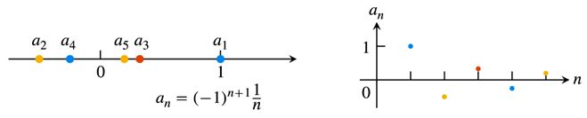



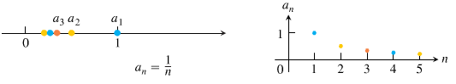

Also, we can write: 

**Convergence and Divergence**

 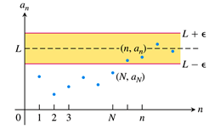

 Terms approach 1.

 Terms approach 0.

***Definition***

The sequence  ***converges*** to the number *L* if for every positive number *ε* there corresponds an integer *N* such that for all *n*,



If no such number *L* exists, we say  ***diverges***.

The  ***converges*** to *L*, we write , or simply , and call *L* the ***limit*** of the sequence.

***Example***

Show that 

***Solution***

Let ε > 0 be given. We must show that there exists an integer *N* such that for all *n*,



This implication will hold if  or . If *N* is any integer greater than , the implication will hold for all *n* > *N*. This proves that 

***Example***

Show that 

***Solution***

Let ε > 0 be given. We must show that there exists an integer *N* such that for all *n*,



Since , we can use any positive integer for *N* and the implication will hold for all *n* > *N*. This proves that 

***Definition***

The sequence  ***diverges*** to infinity if for every number *M* there is an integer *N* such that for all *n* larger than *N*, . If this condition holds we write



Similarly, if for every number *m* there is an integer *N* such that for all *n* > *N* we have , then we say  ***diverges to negative infinity*** and write



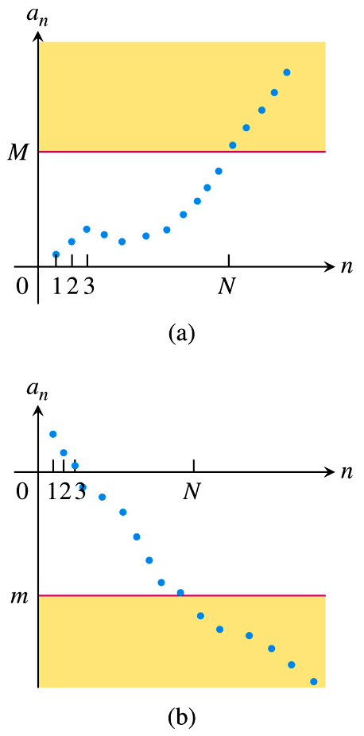 

***Theorem***

Let and  be sequences of real numbers, and let *A* and *B* real numbers. The following rules hold if  and 

***Sum Rule***: 

***Difference Rule***: 

***Constant Multiple Rule***: 

***Product Rule***: 

***Quotient Rule***: 

***Example***

1. 
2. 
3. 
4. 

***Theorem*** − ***The Sandwich Theorem for Sequences***

Let , and  be sequences of real numbers. If  holds for all *n* beyond some index *N*, and if  , then  also.

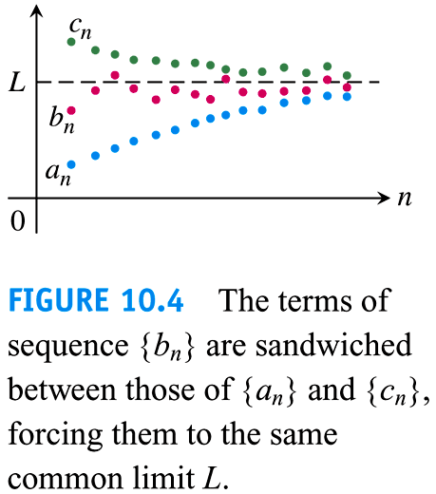

***Example***

Since , we know that

1. 
2. 
3. 

***Theorem*** − ***The Continuous Function Theorem for Sequences***

Let  be a sequence of real numbers. If  and if  is a function that is continuous at L and defined at all , then .

***Example***

Show that 

***Solution***

We know that . Taking  and *L* = 1 that gives 

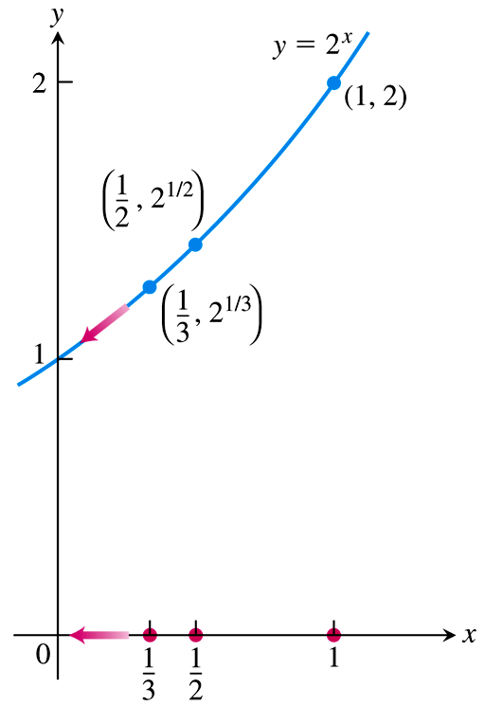

***Example***

The sequence  converges to 0.

By taking , , and *L* = 0.

We see that .

The sequence  converges to 1.

***Using L’Hôpital’s Rule***

***Theorem***

Suppose that  is a function for all  and that  is a sequence of real numbers such that  for . Then



***Example***

Show that 

***Solution***

The function  is defined for all  and agrees with the given sequence at positive integers. Therefore;







***Example***

Does the sequence whose *n*th term is  converge? If so, find 

***Solution***

The limit leads to the indeterminate form .



 **∞.0 *form***

 **0.0 *form***

 









***Theorem***

The following six sequences converge to the limits listed below:

1. 
2. 
3. 
4. 
5. 
6. 

**Bounded *Monotonic* Sequences**

***Definitions***

A sequence  is ***bounded from above*** if there exists a number *M* such that  for all *n*. The number *M* is an ***upper bound*** for  but no number less than *M* is an upper bound for , then *M* is the ***least upper bound*** for .

A sequence  is ***bounded from below*** if there exists a number *m* such that  for all *n*. The number *m* is an ***lower bound*** for . If *m* is a lower bound for  but no number greater than *m* is a lower bound for , then *m* is the ***greatest lower bound*** for .

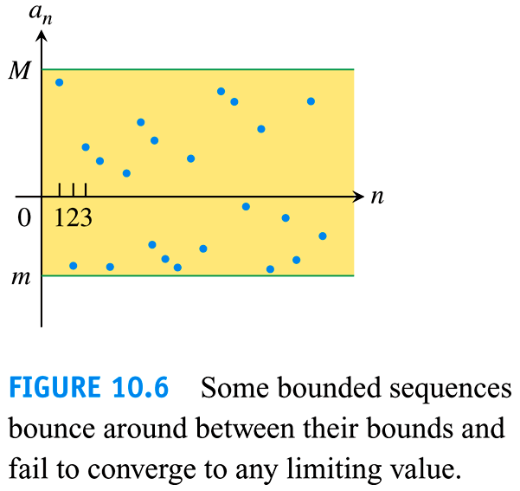

If  is bounded from above and below, the is ***bounded***.

If  is not bounded, then  is an ***unbounded*** sequence.

***Definition***

A sequence  is ***nondecreasing*** if  for all *n*. That is 

Which each term is greater than or equal to its predecessor 

***Example***: 

A sequence  is ***nonincreasing*** if  for all *n*, which each term is less than or equal to its predecessor 

***Example***: 

The sequence  is ***monotonic*** if it is either nondecreasing or nonincreasing.

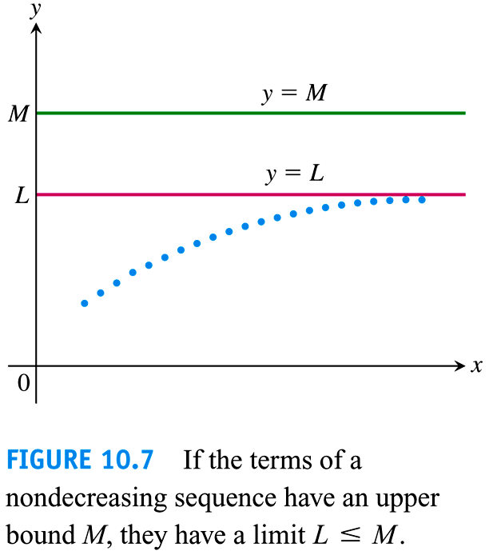

***Theorem***

If a sequence  is both *bounded* and *monotonic*, then the sequence converges.

***Example***

The sequence {1, 2, 3, …, *n*, …} is nondecreasing

The sequence  is nondecreasing

The sequence  is nonincreasing

***Exercises*** ***Section* 3.1 – Sequences**

1. Find the values of for 
2. Find the values of for 
3. Find the values of for 
4. Find the values of for 
5. Find the values of for 
6. Write the first ten terms of the sequence 
7. Write the first ten terms of the sequence 
8. Write the first ten terms of the sequence 
9. Find a formula for the *n*th term of the sequence 
10. Find a formula for the *n*th term of the sequence 
11. Find a formula for the *n*th term of the sequence 
12. Find a formula for the *n*th term of the sequence 
13. Find a formula for the *n*th term of the sequence 
14. Find a formula for the *n*th term of the sequence 

(**15 − 43**) Determine if the sequence converge or diverge? Then find the limit of each convergent sequence.

|  |  |  |  |  |  |
| --- | --- | --- | --- | --- | --- |
|  | | |  |  | |
|  |  | | |  | |